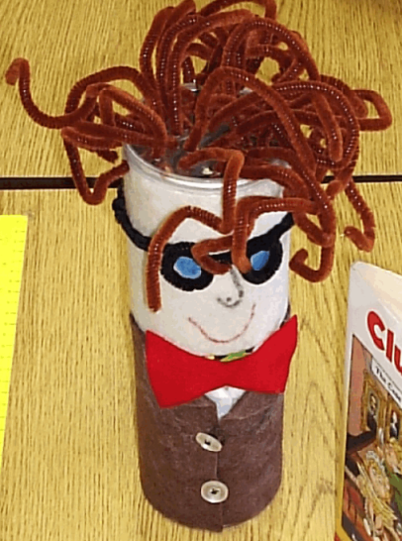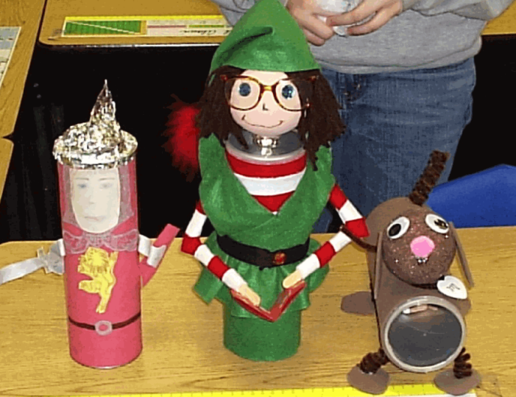
Can Character Book Report
Each student will be required to choose a book to complete this report and an empty Pringle’s size can. Once the book has been read, students are expected to dress the can as though it were the main character of the story. Students can use cloth, buttons, yarn, or whatever they choose in the design of their “character can”. Students are expected to place 5 items inside the can that represent the character, the event(s), and/or the setting. For example, for The Three Little Pigs, the can may contain straw, twig, brick, small plastic wolf, etc.
The attached Report Form should also be turned in with the can.
Upon completion of the report, the student will be expected to share his/her character can and its contents with the rest of the class. Students should practice their presentation at home so they can stand in front of the class confidently.
The students will be evaluated on the following:
- Character Can: completed neatly, this should be the student’s own work- parents can help glue.
- Report Form: See requirements on attached form.
- Appropriate items for book
- Presentation: report is given in a confident manner, can explain Character can completely, and can read the report fluently.

Name _____________________________________

Report Form
Title ________________________________________________

Author ______________________________________________

Main Characters ______________________________________

Setting ______________________________________________

A brief summary of the plot (2-3 sentences)
____________________________________________________
____________________________________________________
____________________________________________________
____________________________________________________
____________________________________________________
____________________________________________________

